**ICICI Queries Part 2**

1. **Standard offer rules template**

The offers do not have a standard template, they are configured as per the business requirements. However, the basics of offers and the attributes used while configuring the offer regarding to ICICI’s context is as follows,

**Type of offers**

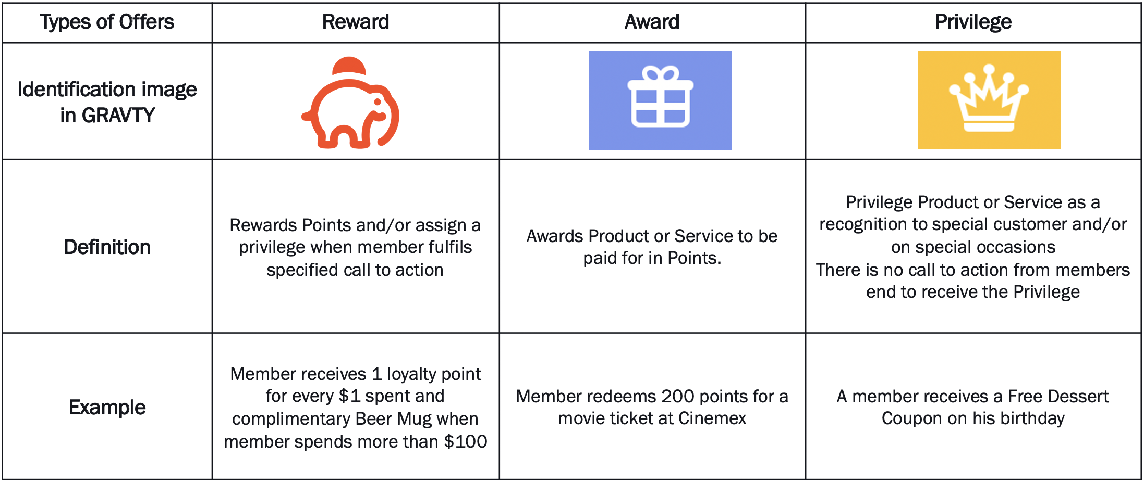

**Different offer status**

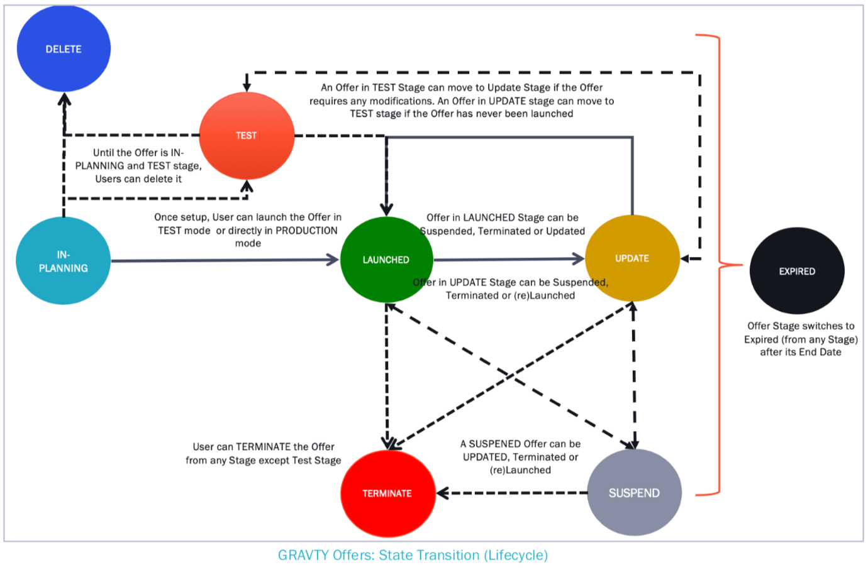

**Offer Rules**

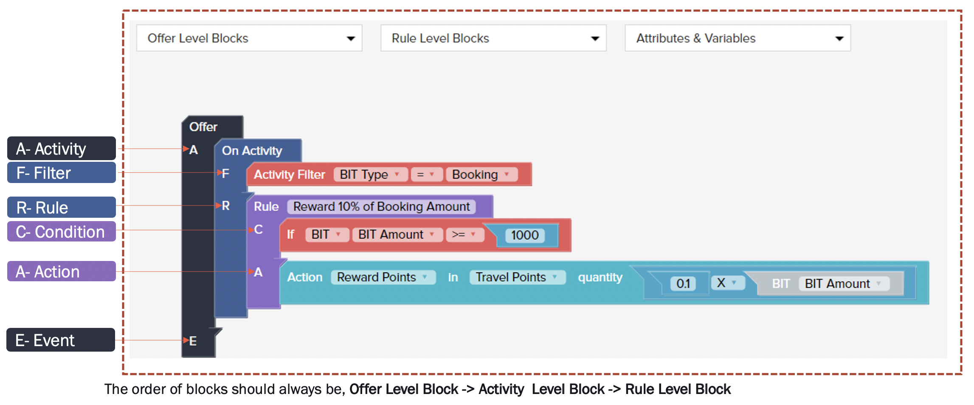

In the offer rules in activity block we put the transaction level conditions like amount of transaction, type of transaction, source of transaction, TID, MID etc. when we click on the block after activity filter it gives us the list of transaction attributes that are configured.

1. **If there are 2 segments in a particular offer, the 2nd segment being nudging of the offer. How does it work, do we need to share the file multiple times after refreshment of data?**

The nudging will be configured based on events in the Marketing Setup available in GRAVTY. In the marketing setup we need to specify the event for which we want to trigger the communication. It could be at offer launch, first communication, second communication. On each trigger we need to configure an event in Marketing Setup.

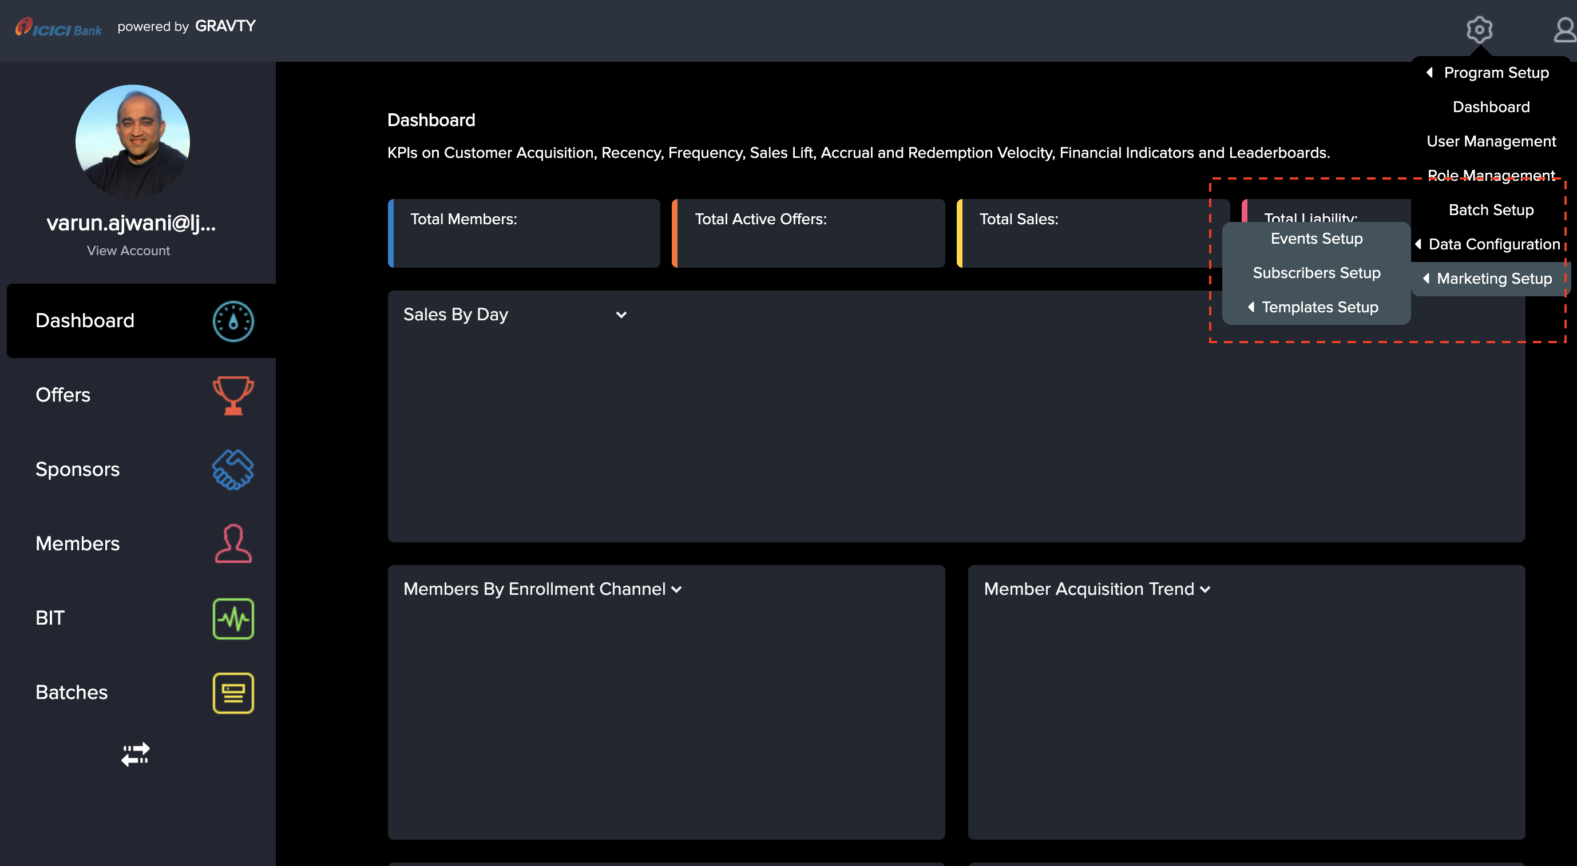

Event setup for offer launch communication

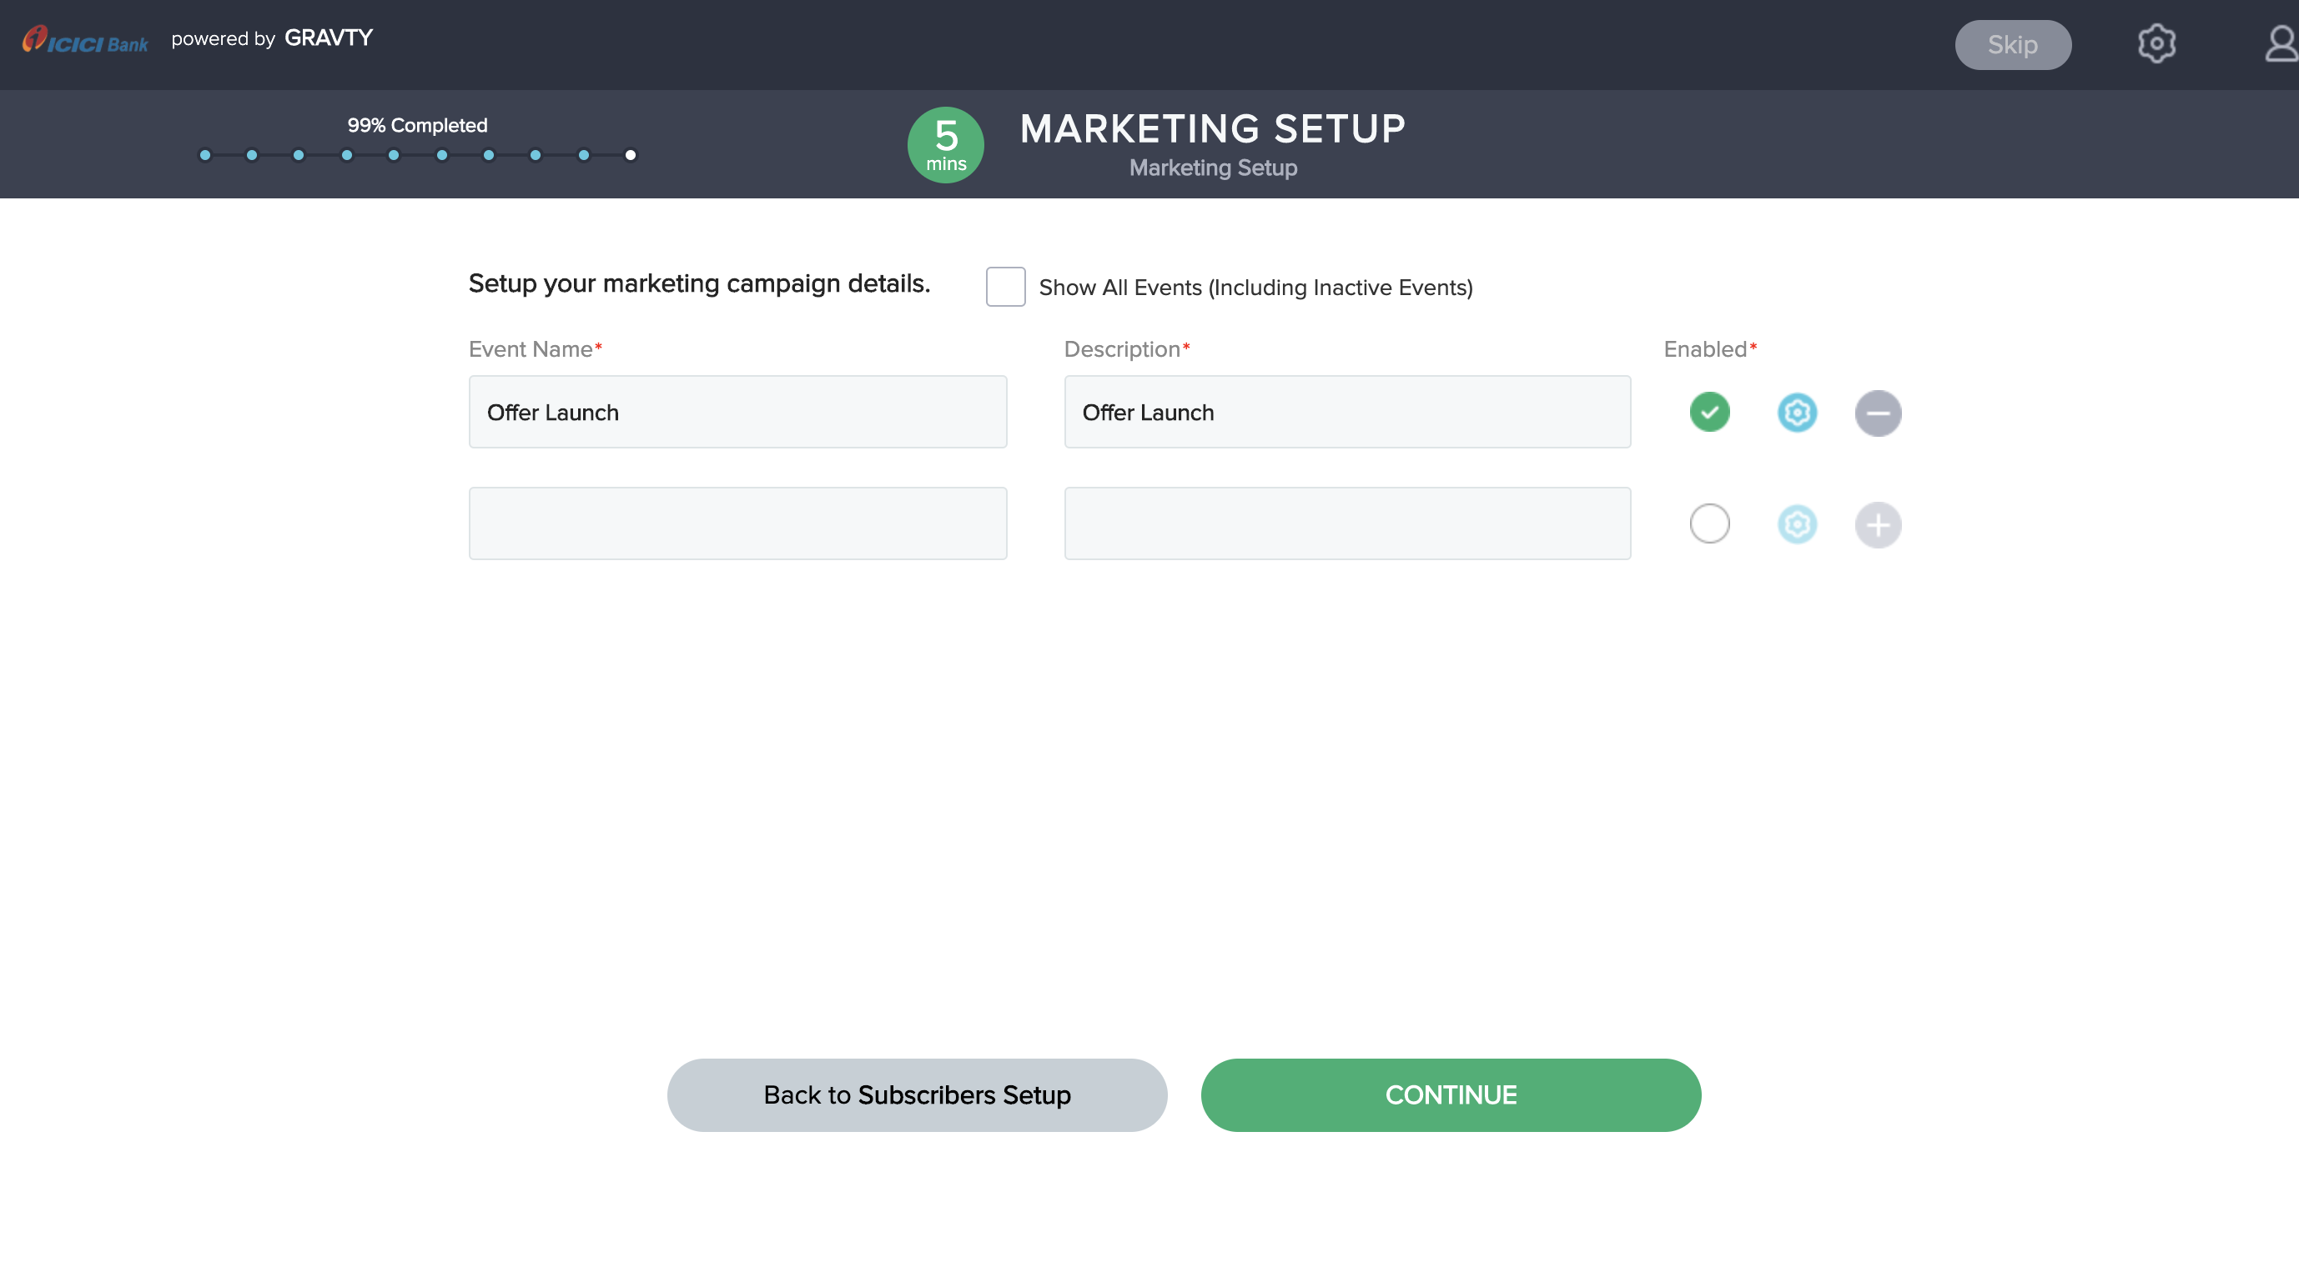

Trigger setup for offer launch communication

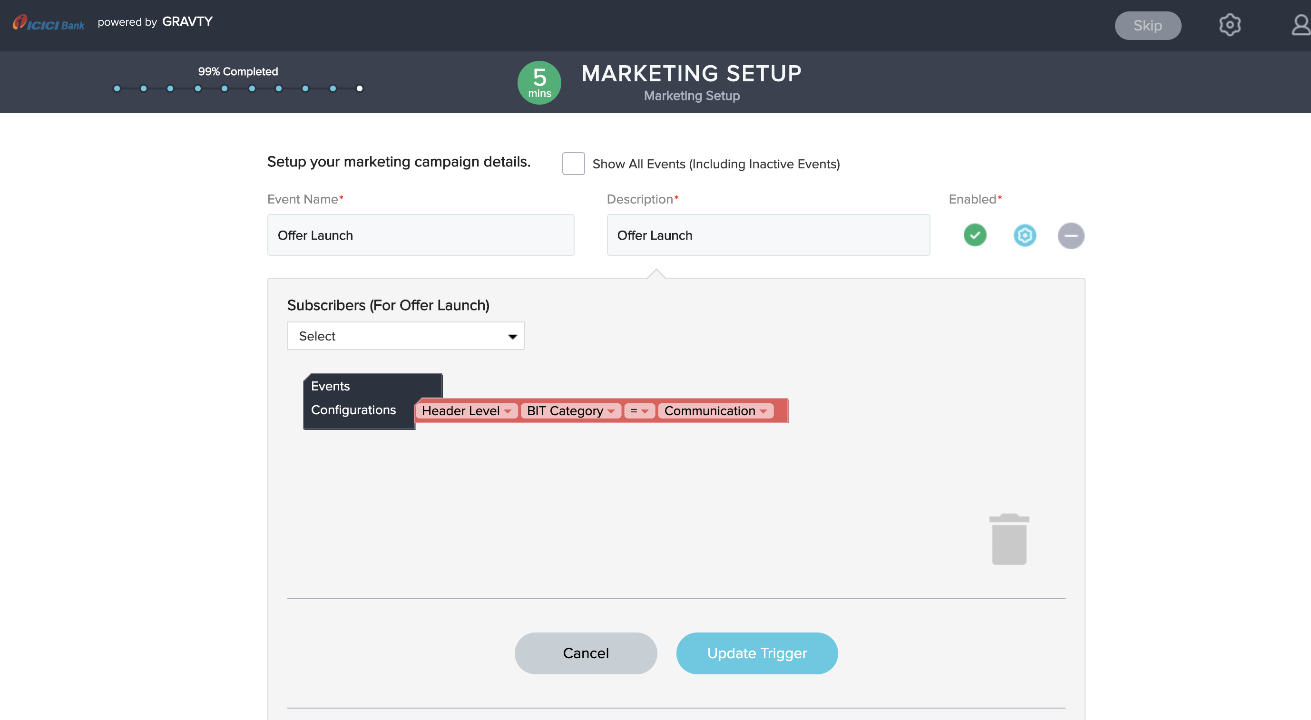

Mapping of attributes for communication

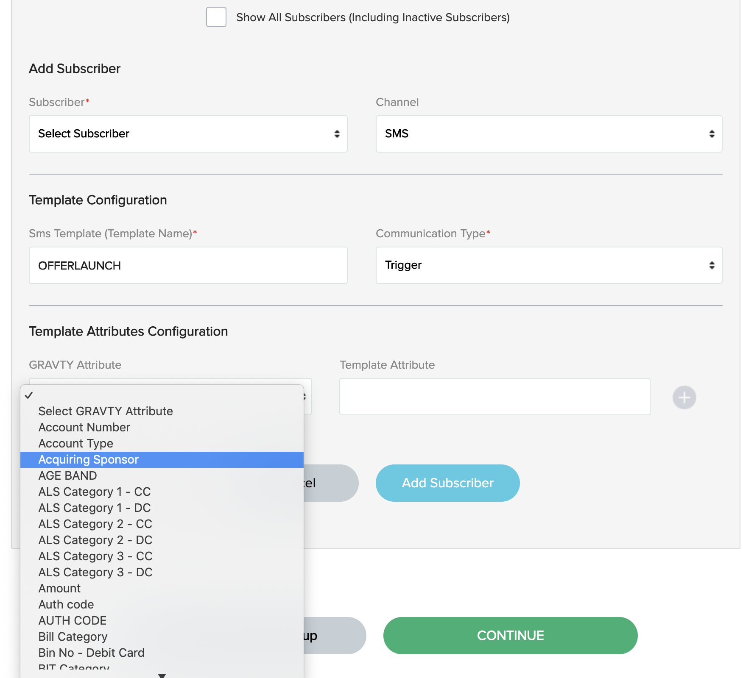

1. **What is desktop banner? Will it get displayed in RIB or offer page?**

Desktop banners are used when we have to display the offers on a website or a portal. The configuration of desktop banner is not mandatory and can be skipped as we are currently implementing only for iMobile.

1. **GRAVTY to show template no. of communication to be sent**

The template number/name can be configured in the Marketing setup – events- template name.



1. **Communication sent count to be flown back to GRAVTY by campaigns team for better tracking**

Need to discuss, how this information be used in GRAVTY?

1. **All Communication creatives to be displayed on GRAVTY**

GRAVTY will send the attributes configured for the communication, creatives are not configured in GRAVTY for the communication.

1. **How do we communicate CC& DC combined offer?**

The communication will be based on triggers, for whatever event the trigger is set in the Marketing connect the trigger will send the communication to the API’s. If offer is launched only for DC members then at the time of offer launch we can send a communication which will be sent to DC members. Communication for offer launch are always sent to target members only.

1. **How do we schedule communication on a later period?**

Later communications cannot be setup in GRAVTY as communications is always sent to the members based on a certain trigger like redemption, accrual, spend, tier upgrade, downgrade, offer launch etc. The communication needs some trigger to start.

1. **How will the priority of redemption work?**

Offer redemption happens based on member, whichever offer member tries to redeem will be redeemed first from the available offers.

1. **Type of Fulfilment**

Question not clear

1. **Please update on Voucher code status**

The enhancement to upload a list of voucher codes for a particular offer is in the roadmap and will be available at the time of launch. In the enhancement user will be able to upload a list of codes that are to be rewarded to the members for a particular offer.